Message from the Chapter President

Sisters,

How quickly time flies when you have a new baby! Thank you to each of you that reached out when Ethan was born and for those of you that went out of your way to bring us a gift and a meal. It is all very much appreciated. It is these moments that you are thankful to have sisters who are thinking of you. We are settling in to being a family of four and I return to work just after the new year. It seems like just yesterday he was born!

We’ve had a great Fall so far and I’m looking forward to all the great things we have planned for the Spring. As always, I hope to see each of you at our events. If you have any ideas for fundraising activities, please let me know as we are always looking for something fun and meaningful to do.

It is bittersweet to announce that Suzanne Chamberlain is not seeking re-election for treasurer for the 2020-2022 term. Suzanne is an integral part of our chapter and has been an active member for many years. Suzanne, we are thankful for your service to our chapter and to Alpha Chi Omega. If you are interested in volunteering for treasurer, please let me know, as we have big shoes to fill!

I hope you all have a warm and happy holiday season.

Alpha Chi love and mine,
Leah

Inside This Issue
1 Message from the President
2 Red Carnation Dinner a Huge Success
2 Explore our Digital History Books
2 Feed My Starving Children
3 Welcome Ethan Fredbeck
3 Alpha Chi Omega Night Out
4 Become a Mentor
4 Trivia Night
4 Household Goods Collection
5 Luxe Fundraising Event
5 ACA Update
5 Panhellenic Benefit Update
6 In Memoria
6 2020 National Convention news
7 Calendar of Events
7 Officer Listing

Like us on Facebook at:
Alpha Chi Omega - Iota Lambda Iota
Visit us on the Web at:
www.IotaLambdaIota.com

Iota Lambda Iota Alumnae Chapter of Alpha Chi Omega
Lake County, Illinois

January 2020

Hera’s Herald

Red Carnation Dinner – Sunday, September 18th

Red Carnation Dinner a Huge Success
Thank you to Kourtney Passarella for opening her home and feeding us well, at our September Red Carnation Dinner. 15 Alpha Chi Omega members attended.

Kourtney provided tasty pasta and sauces with members adding salads, appetizers and desserts to the menu. Members also brought along donations for A Safe Place.

An overflowing grocery cart of paper goods, household items and diapers were delivered to A Safe Place, Zion on the following Monday. A Safe Place was overwhelmed with our chapter's generosity.

Thank you all and a special thank you to Kourtney.

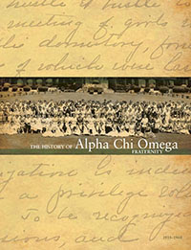
Explore Our Digital History Books
The third installment of The History of Alpha Chi Omega Fraternity is now available online! Learn about the women, the decisions and the climate of our country that changed the course of Alpha Chi Omega during 1935-60. What did recruitment look like as the process became more formalized on campuses? How did World War II affect conventions, housing and the sorority experience as a whole?

This third volume is accessible digitally on the Our History page of our website and is joined by digital versions of the first two history books covering 1885-1910 and 1910-35. Dive into our history and share it with your chapter members!

Feed My Starving Children
Ann Marr, Andrea Franks, Kathy Marks, Lynne Lenz and Molly Jostock joined many other volunteers for a wonderful evening of packing food at Feed My Starving Children. The entire group, in 75 minutes, packed enough food to feed 31 children for one year.

We had so much fun and did so much good, let’s do it again.
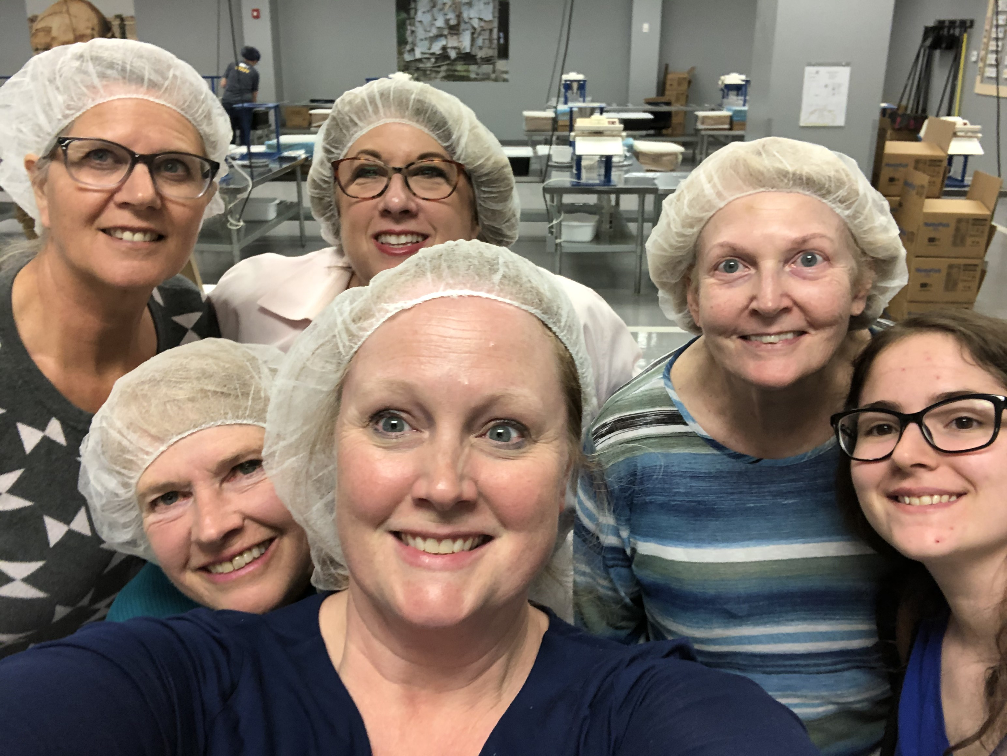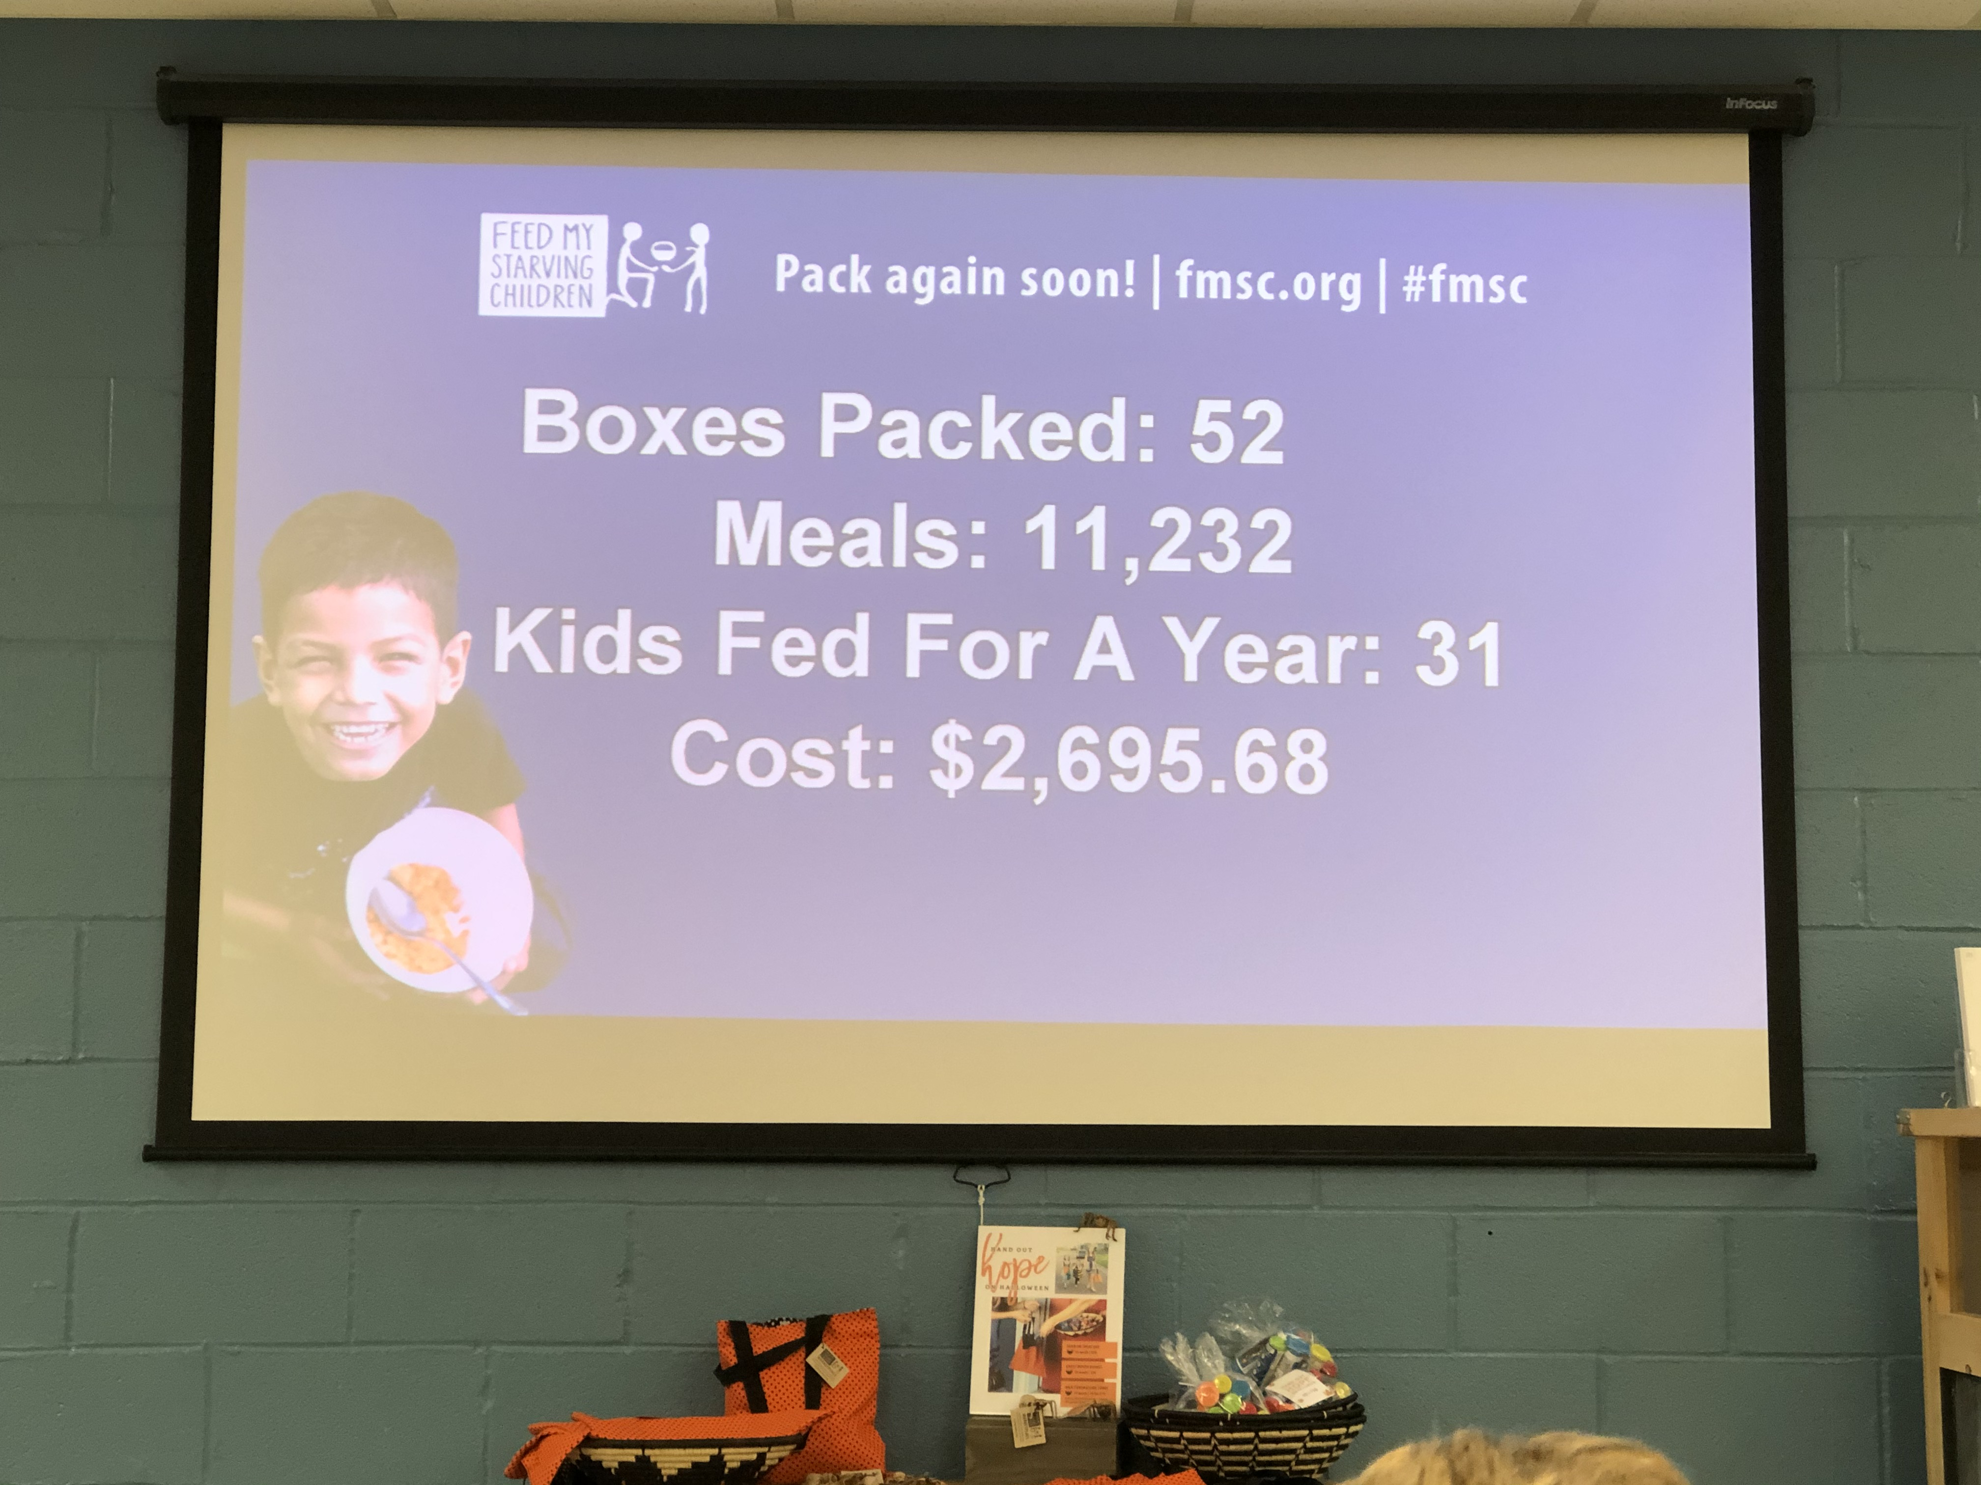

To MISSION:

Welcome Ethan Fredbeck!

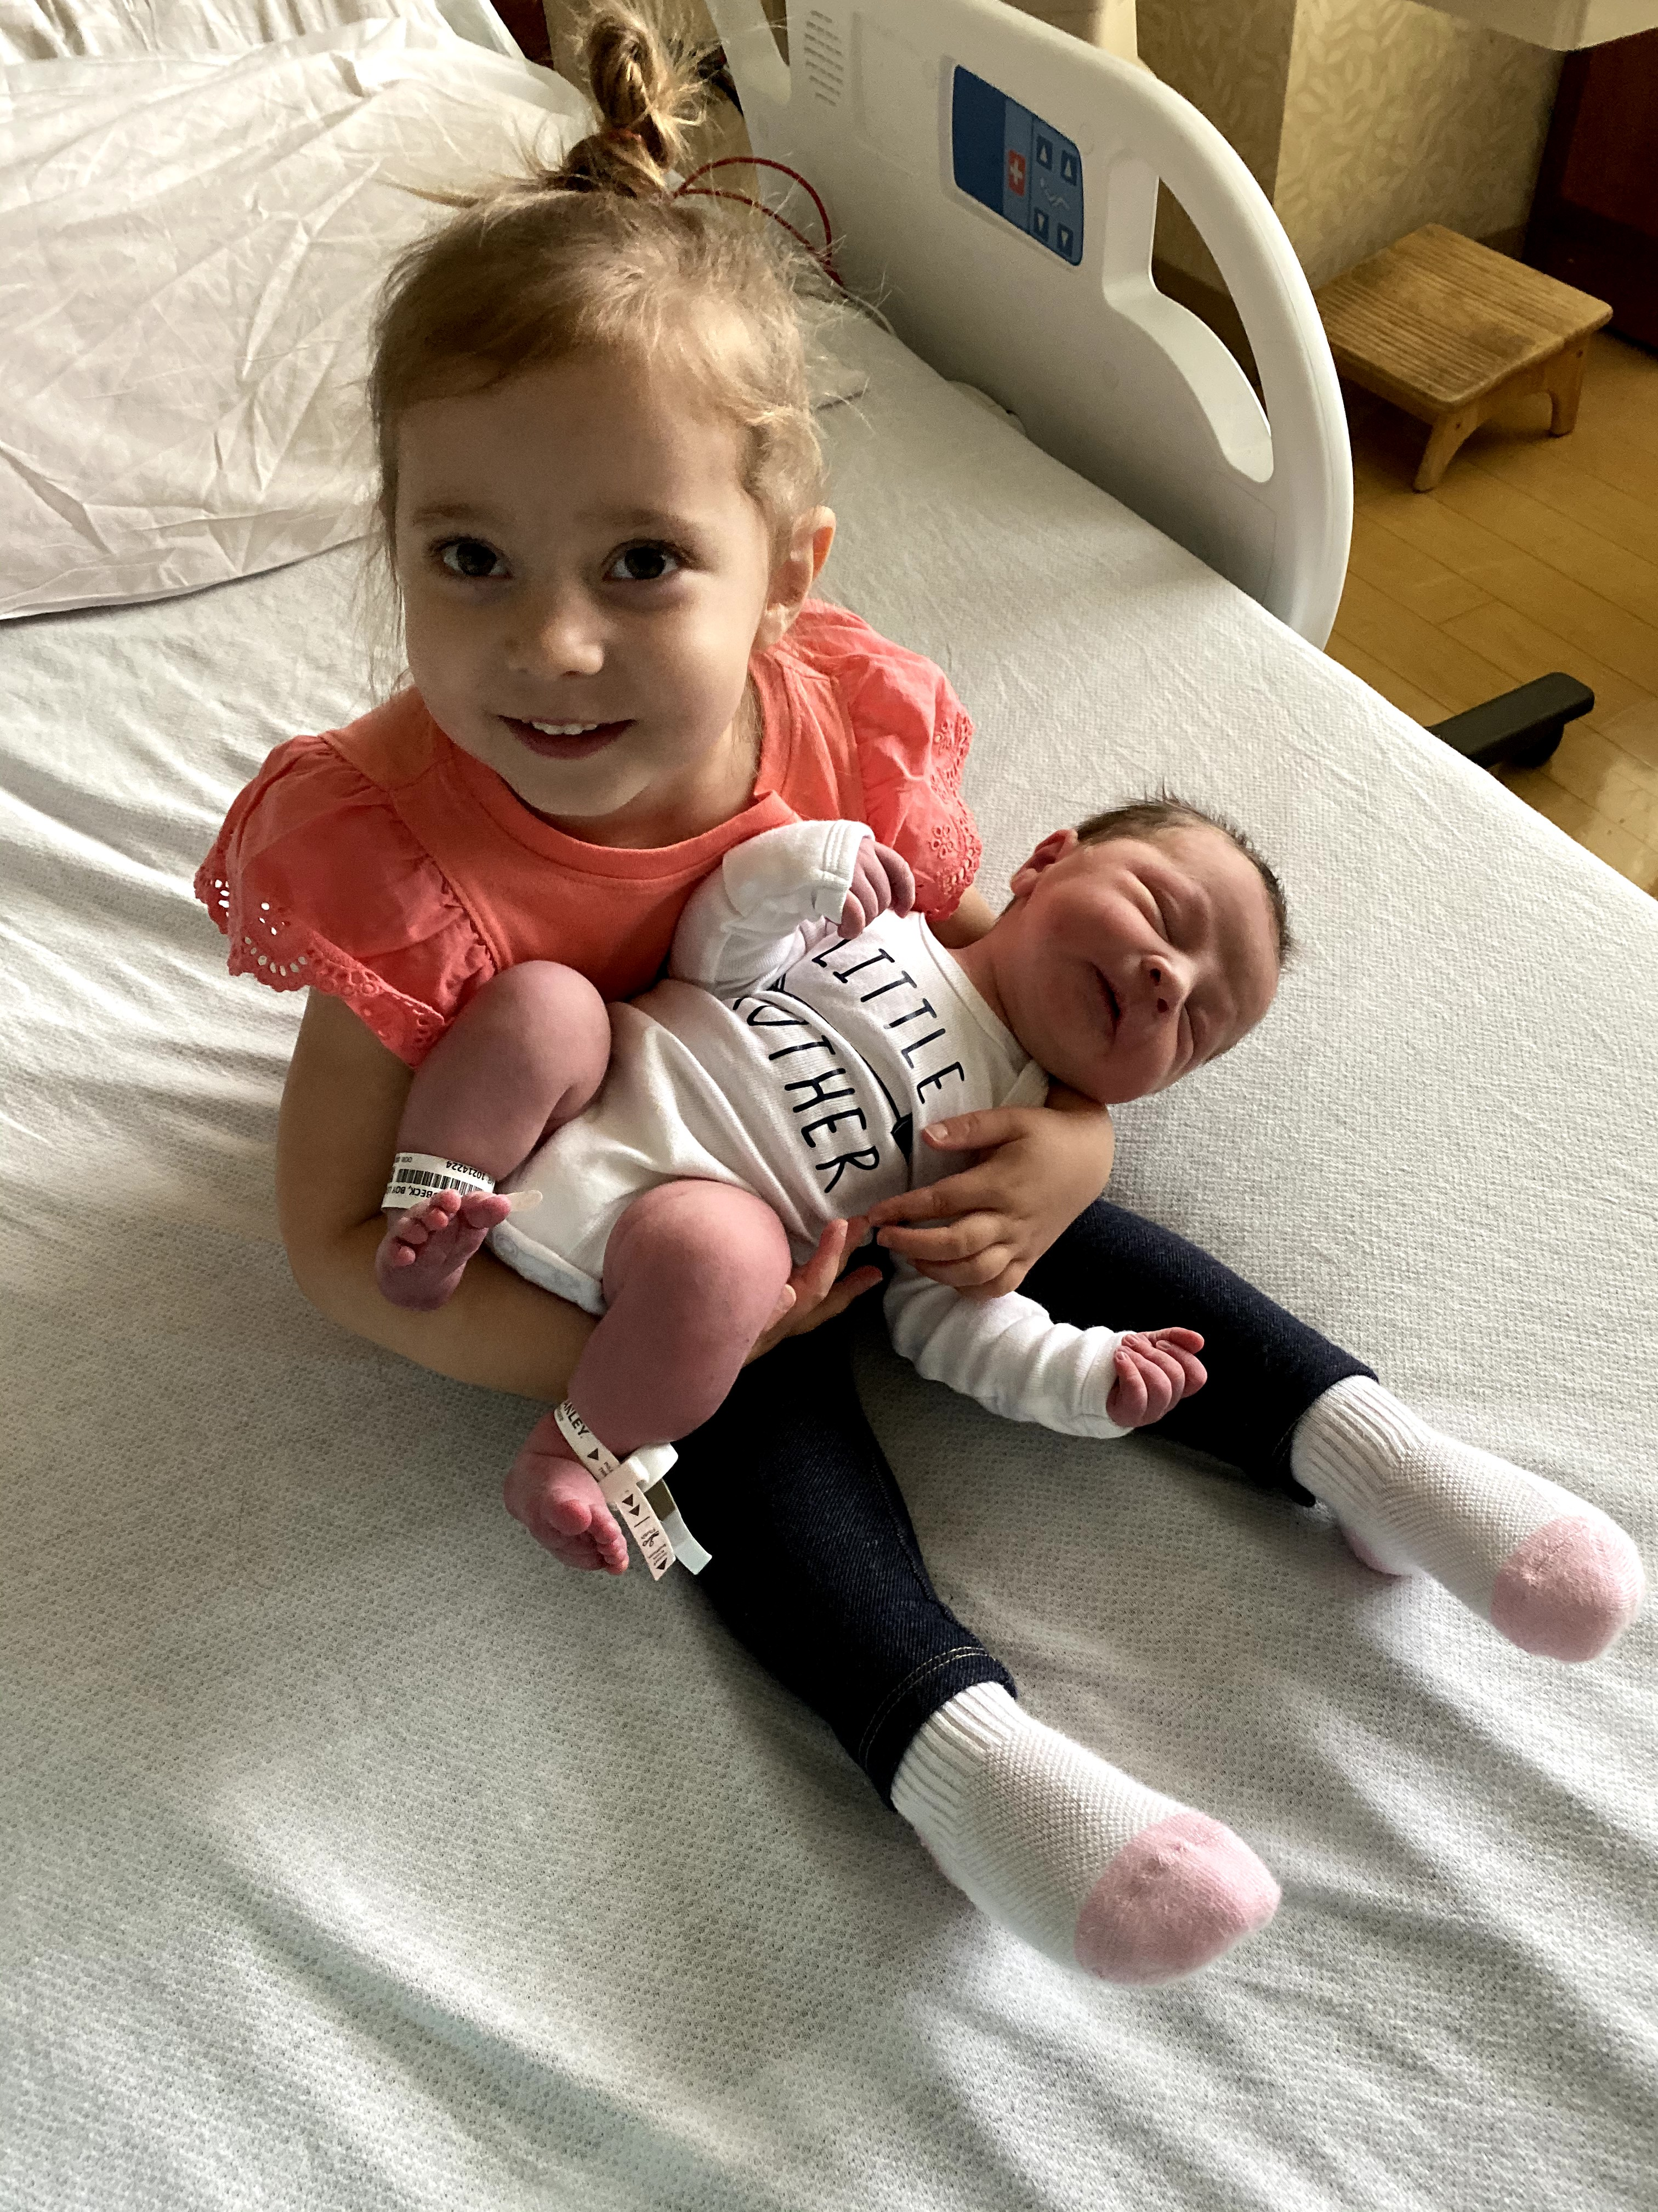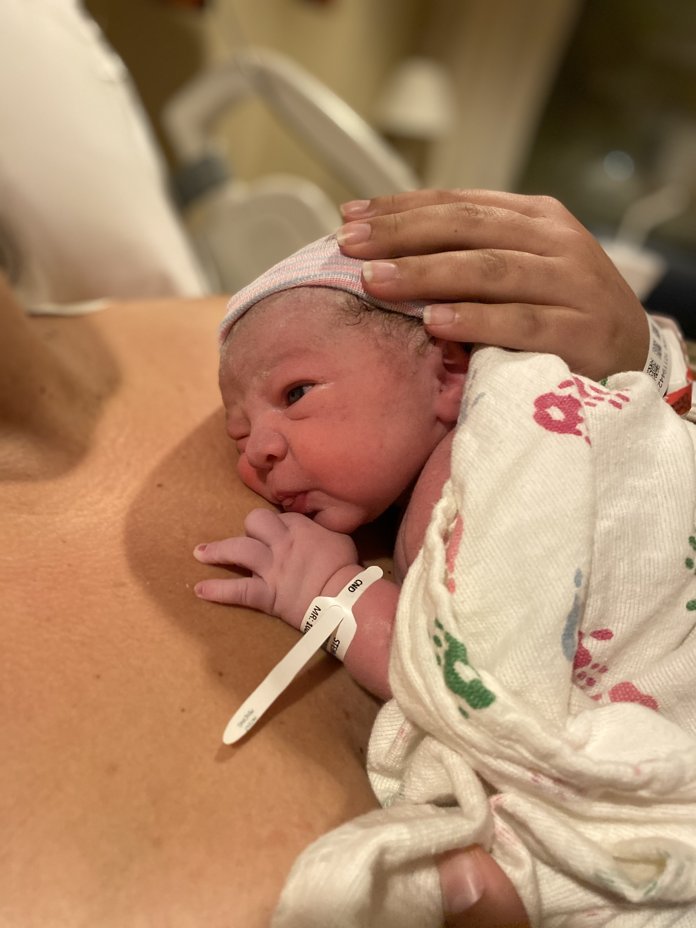

Welcome at
Ethan was born on October 10th to Leah and Jon. He’s already been to a few meetings!

Alpha Chi Night Out
As part of Healthy Relationships Week, alumnae worldwide are invited to come together for Alpha Chi Omega Night Out to connect with one another and celebrate our sisterhood.

On Tuesday, February 11, 2020, make plans with a sister! Our goal is to engage as many sisters as possible in a fun night (or day) of fellowship and sisterhood. On the Tuesday of Healthy Relationships Week, Alpha Chi Omega asks our members to make plans with sisters in their area.

Here are just a few ideas to get you started on your planning: coffee, drinks, brunch, doing something active, playdates, shopping in person or a Skype/FaceTime/phone call with a sister in another city, state or country. There is no expectation for what you should do, other than enjoy the company of another Alpha Chi Omega!

Join us as we celebrate Alpha Chi Night out on Wednesday, February 12th at 7pm for a cannoli making class at Tony Cannoli in Mundelein. We will roll, form, & fill 3 cannoli, you get a choice of Italian soda, signature filling tasting, Pallini limoncello tasting and 10% off all items at the time of class. Cost is $25 per person and will be collected at the class.

Become a Mentor and a Mentee with Women & Wisdom
Have you joined Women & Wisdom yet? Women & Wisdom is Alpha Chi Omega’s premier online networking program that will allow you to sign up to be a mentee and/or a mentor to other Alpha Chi Omega members around the country! This interactive experience provides resources and tutorials to help guide mentors and mentees in developing impactful relationships, achieving goals, and gaining new skills and competencies.

Did you know: Alumnae have the opportunity to participate as mentors, mentees or both! Collegiate members in their junior and senior year are invited to participate as mentees. Get started by creating your mentoring profile today!

Mentoring sessions consist of three 1-hour meetings or sessions through a mutually selected platform such as Skype, FaceTime, Google Hangout, on the phone or in person. The expectation is that all three sessions are completed within the year; however, we hope your mentor/mentee connection continues beyond the scope of your sessions!

Sisters who are participating as mentees drive the matching process. They can search mentor profiles based on industry or professional interests. The mentee will reach out to a mentor to make the connection.

Interested in joining? Visit our Women & Wisdom page on the Alpha Chi Omega website. You will need to log into the Alpha Chi Omega website in order to sign up for the program and create your profile. There is also an informative orientation video available to get you acquainted with the program. If you have any questions, please email mentoring@alphachiomega.org. We hope you will join us (and encourage others to participate) in this exciting mentoring experience!

Trivia Night at Austin’s – January 22 at 7:30 pm
Food, drinks and trivia – it will be fun! Watch for an evite coming soon and plan to join us. We will have a table – come at 6:45 if you want to have dinner, otherwise, come at 7:15 with your thinking caps on.

Household Goods Drive – all of January
Please contact your neighbors, your church, your sports club and ask for their slightly used houshold goods. Your neighbors, friends and other groups will appreciate our elfforts as they get to finally clean out their closets and kitchen cupboards.

Ann Marr will take all collected items to A Safe Place to help these families transition into healthier lifestyles and living arrangements.

Lake County Haven has also secured a second site for a transitional shelter and needs our help to make it home! They have a wish list to shop from Target and a list of items they are looking for on their website.

Luxe Wearhouse Fundraising Event
A small group created a nice donation for our chapter when they attended the Luxe Wearhouse event on November 14th. 3 chapter members and 2 of their friends found wonderful clothing and the chapter received a $105.00 donation.

Let’s try this again and hopefully more people will attend and we will then have more money to donate to our philanthropies!

Update on the College Affordability Acct (ACA)
(from the National Panhellenic website)
The US House of Representatives Education and Labor Committee passed the College Affordabilty Act on Oct. 31, 2019. This massive higher education bill includes strong protections for students joining single-sex organizatons and represents the most important action taken in Congress since the issuance of Title IX in the 70’s.

The ACA would prohibit insitituions of higher education from taking an adverse actions (i.e. denying participation in any sports team, club or other student organization, including a denial of any leadership position in any sports team, club or other student organization) against a student solely because the student is a member of a single-sex organization. The bill also requires better tracking of hazing incidents. While this is just the first step in the legislative process, it is also a significant one.

Panhellenic News - North Shore Panhellenic Benefit
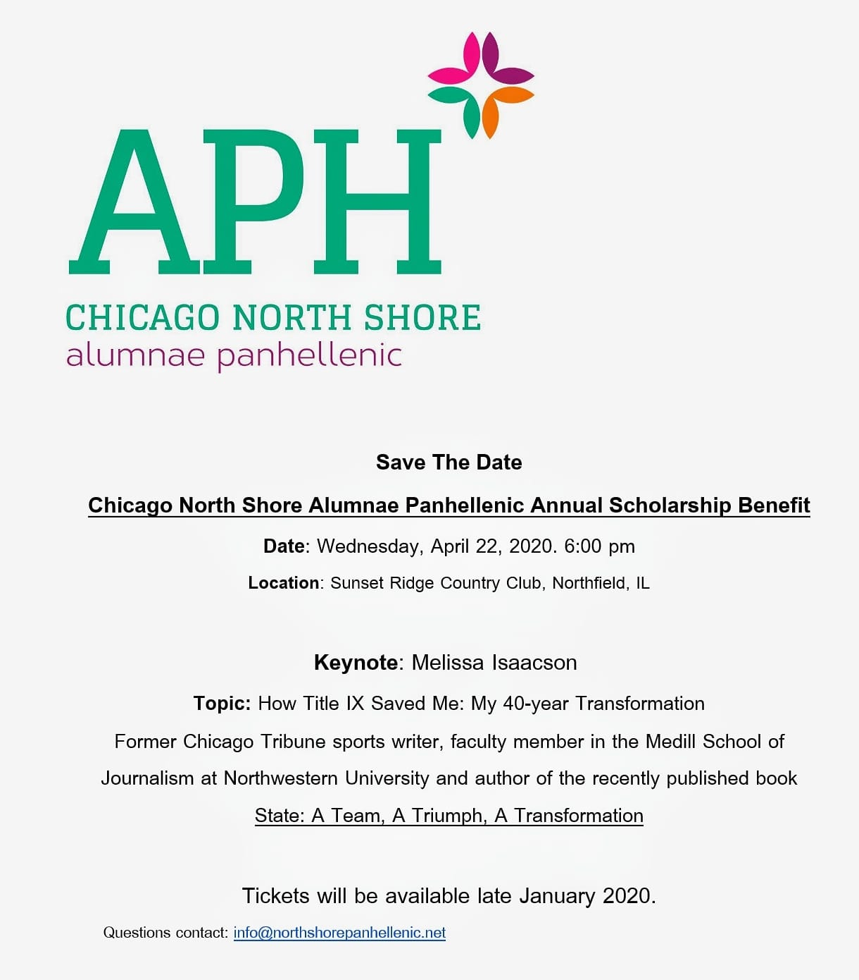
The speaker has been chosen for the Cicago North Shore Panhellenic Benefit on April 22, 2020. The theme is still being decided upon but will be published soon.

Melissa Isaacson, a published author, (How Title IX Saved me: My 40-year Transformation) and sports writer, has witnessed and lived the arc of Title IX. For many of us, Title IX meant that we could participate in sports, but it has morphed into much, more (i.e. housing, sexual assault litigations and rulings and so much more).

Please save the date for this insightful program and fellowship with the panhellenic community.

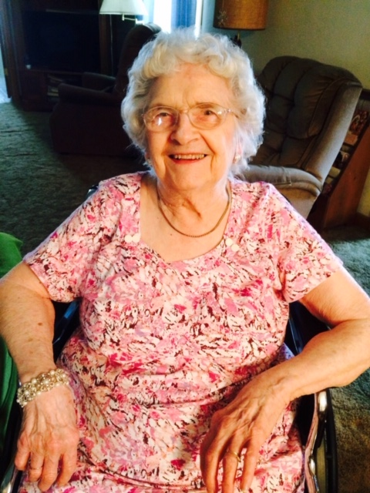
In Memoria – Margaret Wenzinger
Jan Curschman’s mom passed away peacefully December 4, 2019 after a month in hospice. While she will be missed dearly, the family is happy that she is no longer uncomfortable. What a long, beautiful, happy life she had for 98 years – sharing the smiling face and twinkling eyes they will always remember. She always loved cooking up some meal for any friend coming to her beloved farm. Thank you for all your prayers. God has blessed Margaret!

Save the Date for Alpha Chi Omega’s 61st National Convention
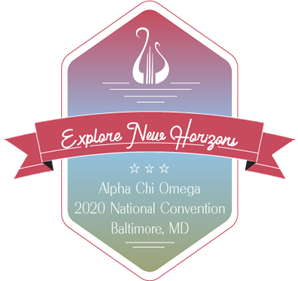

On June 26-28, 2020 join more than 1,000 sisters at the Baltimore Marriott Waterfront at the historic Inner Harbor of Baltimore, Maryland.

Explore new horizons with Alpha Chi Omega at this weekend of sisterhood. Grow personally and professionally through education sessions, celebrate the achievements of the last 2 years and renew your connection with Alpha Chi Omega. Registration will open in Frebruary 2020 at alphachiomega.org. A schedule of events can be found on the Alpha Chi Omega website.

2019-20 Program Calendar

January
22 – Trivia Night – Austin’s, 481 Peterson, Libertyville
All month - A Safe Place household drive from your neighborhood

February
12 - AXO Night Out – Tony Cannoli’s Mundelein

March
12 – Bunco, Ann Marr’s, Libertyville

April
16 – Book Club - Carol Myers & Christy Dunnick
22 – North Shore Panhellenic benefit, Sunset Ridge Country Club, Northfield
24 – Chicago Master’s Singers – Beethoven Concert, Northbrook. Drinks following the concert

May
TBD – Mother’s Day Party
TBD – A Safe Place Benefit
Iota Lambda Iota - 2019-2020 Elected Officers

President – Leah Stein-Fredbeck
Vice President of Membership - Kourtney Passarella
Treasurer - Suzanne Chamberlain
Secretary – Ann Marr
Ways/Means – Kathy Mark
Programs – Wendy Weigers
Social Media - Leah Stein-Fredbeck
Panhellenic Rep –
Panhel. Alternate – Ann Marr
Courtesy Chair – Carol Meyers
TBD - Empower Run

June
TBD – Installation Dinner

